CAT-6 Cables that Work and some that Don’t Work
Although our MV-VSD communications has not changed, later models of HP laptop computers used by JCI require a higher bandwidth Ethernet cable to communicate. For newer laptops such as HP Elitebook 8460p, 8470p, and 8560w, the cable no longer needs to be a crossover cable – however it must be a CAT6 rated cable capable of operating above 200 Mhz!

Approved Cables – tested with new JCI HP laptops and MV-VSD

Best Buy – Rocketfish 14’ CAT-6 Network Cable Model: RF-PCC107 SKU: 9695611 $26.99

This is the best CAT-6 cable we have found. It is a significantly thicker cable material 0.250” diameter. We expect all lengths (4’, 8’, and 25’ available) of this same cable should likely perform equally well. If you need to purchase a CAT-6 cable and do not have a Best Buy store in your area, we suggest you order one of these online from Best Buy and have it shipped to you.

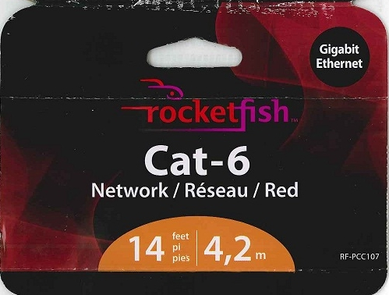

Staples – “Staples Brand” CAT6 Supreme Networking Cable Model: 18784 Item: 837377 $26.99

This cable has been tested and found to work reliably. It is not nearly as rugged as the Rocketfish cables and most likely does not have quite as high bandwidth. It is only 0.200” diameter, and visibly appears similar to many other CAT6 cables we found do not work. However the one we purchased has proven to work repeatedly and we would suggest this as a back-up source if you find you need a cable immediately and cannot locate a Best Buy store in your area.

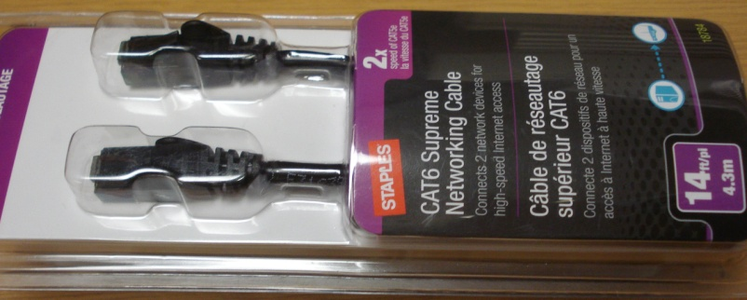

On the following page are several additional cables labeled CAT6 but found do not work with newer JCI laptops communicating with our MV-VSD products.

Cables labeled CAT-6 but DO NOT WORK!

Radio Shack – “Gigaware” CAT6 Network Cables - It is a shame Radio Shack does not offer a higher quality product, since their distribution is so wide-spread nationally. Perhaps in the future they might add additional cable offerings. However the Gigaware cables from Radio Shack did not work for us.
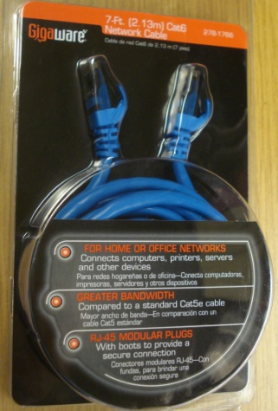
Walmart – Neither CAT6 cable offered at Walmart worked with our product. We tested the following:
ONN Platinum 7ft Premium Network Cable Belkin Premium Flat High-Speed CAT6 Cable

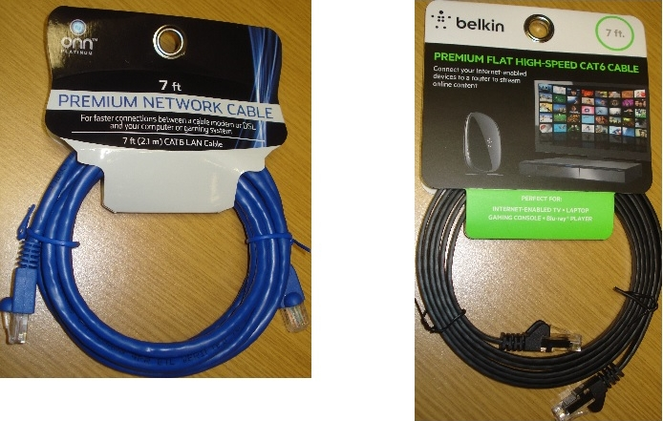

Egghead (Mailorder) – Rosewill High Quality Cable CAT6 Crossover 14’ Model: RCW-720 – We purchased several of these due to the attractive price, however none of them worked with the newer JCI laptop computers. They did work on the older PCs which also worked with CAT5 crossover cables.

