PAGE: 1 of 5
GENERAL SYSTEM OPERATION

ANTI-SURGE CONTROL - DESUPERHEATING RECYCLE GAS - PRESSURE REGULATION

Sandridge Energy, Job #: 27607-P-13-012JCI, YPS Job #: 294100

Anti-Surge Control consists of four significant aspects - prevention, detection, recovery, and protection.
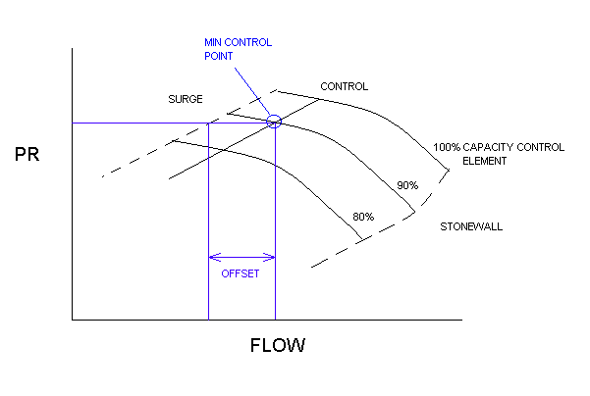Surge prevention, or avoidance, is the practice of anticipating the operating characteristics that will cause surge and manipulating control elements to avoid those characteristics. The primary elements are the recycle control valves. Recycle gas acts to increase compressor flow, which tends to stabilize centrifugal compressors. Figure 1 shows the basic characteristic of pressure ratio (PR) and flow.
Figure 1
The capacity control element is modulated by variable inlet guide vanes. Increasing pressure ratio and decreasing flow tend to move the compressor closer to surge instability. The minimum flow required is the flow at the surge envelope plus some safety margin for each load on the compressor. Once the minimum flow is determined for the condition, a flow control algorithm modulates the recycle valves to maintain flow and stability separately for each of the three section of the compressor.
Generally speaking, the more flow through the compressor, the more power the compressor absorbs. Adding flow indiscriminately, or controlling to a static flow setpoint, increases operating costs.
Surge detection requires special instrumentation to sense the instability caused by surge. Surge is not always easy to detect depending on the intensity and type of the instability. Once detected, it means the prevention has not worked successfully. Detection includes a feature that modifies prevention in a way that facilitates continued safe operation of the compressor.
Surge recovery results when corrective action is taken based on detection and prevention. Something irreversible may have changed, such as a calibration or control element failure, and the flow control should increase the recycle gas to avoid further incidences of surge.
Protection requires that the compressor be shut down if continued unstable operation cannot be avoided.
Desuperheating Recycle Gas is typically done one of two ways, liquid quench or liquid injection.
Liquid quench is the practice of taking recycle gas off the discharge line and directing it into a low temperature liquid supply. Most often this is done by returning the gas into the evaporator below the liquid level. This hot gas is desuperheated by boiling a portion of the liquid in the evaporator off reducing the temperature of the entering hot vapor.
Liquid injection is the practice of injecting low temperature liquid into the pipe run downstream of the recycle gas valve. This is accomplished though rapid expansion of high pressure liquid and specialized piping arrangements.
Side Load Pressure Regulation consists of manipulating pressure drop in pipe runs to allow more stable flow and process conditions.
Pressure regulation is used as a way to stabilize the pressure of the side load process. Pressure regulating valves are typically used with pressure sensing devices to control fluctuations in process conditions.
Discharge Pressure Regulation is performed in a similar fashion as side load regulation.
A pressure regulating is supplied in the discharge line and controlled off a pressure sensing device. This practice is typically performed to allow a compressor to build high discharge pressure faster.
York Features:

York Process Systems integrates surge control, liquid injection, and pressure regulation into the capacity and sequencing controls within the PLC utilizing several key features:
- Flow Control - Flow is measured directly on the discharge, second stage, and third stage and indirectly on the suction by Annubar type flow transmitters (FT-1231A1, 2, and 3). Flow is controlled on all independent inlet flows to the compressor by individual recycle valves. The Annubar type primary element combined with a multivariable differential pressure transmitter provides highly accurate flow measurements. This accuracy is further enhanced by the addition of straightening vanes located upstream of the transmitter.
- Variable Flow Setpoint(s) - The minimum amount of recycle gas needed to avoid surge in each stage is a function of the characteristic performance and the compressor pressure ratio. For a job with multiple compressors running in parallel the pressure ratio and capacity controller process variable are based on one suction header pressure signal for each compressor. This will allow all compressors to share loads equally when pulling suction from a common point. The measured pressure ratio is used to calculate the minimum compressor flow for each stage. York calculates the minimum recycle flow needed in order to minimize compressor power based on estimated compressor performance curves and minimum compressor turn down. To further protect each compressor a signal decoupler has been integrated to allow each machine to run off its own local suction pressure signal if that value deviates from the header pressure signal by more the 2 psi (adjustable 0-10).
- Offset (Bias) - A safety margin must be included in the calculated flow setpoints so that operating fluctuations will not trigger surge (I.E. Control Margin). Figure 1 shows the OFFSET bias. The offset is an adjustable minimum differential between calculated surge flow and controlled flow. This offset is increased on the detection of surge, which effectively increases the flow to the compressor. We use 5% default bias between the calculated surge flow and the control point. Once the offset has been incremented due to surge, it remains that way until an operator resets the offset to normal.
- Recycle Valve - The recycle valves use volume boosters as needed to insure rapid valve action. Nevertheless, the controls allow for the tuning of valve ramping rates to match the needs of refrigeration system design, such as avoiding liquid carryover. When sizing recycle valves for a refrigeration system, the required recycle flow is reduced by the amount of liquid injection needed to desuperheat the recycle gas.
- Liquid Injection – Considerable design has gone into the system to ensure that liquid refrigerant will not carry over into the headers. Low temperature liquid is provided by the rapid expansion of high pressure liquid though the temperature control valve for each stage (TV-1231A4, 5, and 6). The cooler liquid is then injected into the pipe runs downstream of the flow control valves (FV-1231A1, 2, and 3) to desuperheat the recycle gas. Specialized injection nozzles and static mixers are used to inject the liquid with a fanned spray into the flow of the recycle gas. Injecting liquid into the flow of the hot gas and the addition of the static mixers allows for better mixing and increased contact area for the liquid to evaporate. To further ensure liquid does not carry over the flow of injected liquid is modulated to maintain a setpoint of 10° superheat. In other words, the recycle gas is cooled to 10 degrees above the refrigerant’s saturation temperature at each stage’s header pressure. This 10° superheat setpoint is calculated/adjusted with actual downstream temperature/pressure measurements (TT-1231A4, 5, and 6; PT-1231A4, 5, and 9) and established refrigerant properties. See figure 2.
- Pressure Regulation – Inlet pressure regulation is also employed to provide a more stable and efficient compressor operation. Using high performance butterfly valves on the inlets of stage 2 and 3 to the compressor (PV-1231A1 and 2) a pressure drop is introduced into the line and maintained to provide a more consistent process inlet variable. As mentioned previously the capacity control suction pressure is maintained by variable inlet guide vanes off a median common header pressure.
Discharge pressure regulation has also been incorporated into this system to allow each compressor to build high discharge pressure faster than it would be able to pressurize a large system such as this one. A high performance butterfly valve (PV-1231A3) is used and controlled off discharge pressure at the compressor. On low pressure signal, startup for example, the control valve will close off the discharge line allowing a smaller area of piping to build pressure. This will allow the compressor to recycle high pressure discharge vapor faster at startup and also bring the compressor up to speed faster than if it needed to pressurize the complete system.
- Detection - A differential pressure switch is used to detect rapid significant reductions in discharge pressure. The measured flow signal is used to detect rapid significant reductions in flow. If either condition occurs, the recycle valve is opened in progressively larger amounts and the offset bias is incremented by an adjustable amount (default 5%) to allow more recycle gas to flow to the compressor until corrective action is taken by operators. The recycle valve ramps to the new control signal at a predetermined rate. On the first detection of surge the recycle valves will open a additional 33%, on the second detection of surge the recycle valves will open to 100%. If stability is not achieved in time to avoid three surges in 30 seconds (adjustable), the compressor is shut down.
- 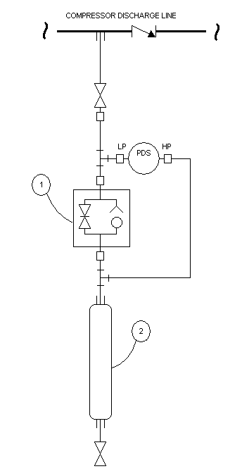Parallel Compressor Detection - When centrifugal compressors are operated in parallel, they act differently than when they operate alone. The discharge pressure generated by another operating compressor may cause the discharge check valve of another compressor to close. The compressor with the lower discharge pressure will likely recycle and may take some time before its check valve opens, if it opens at all. During this period, this compressor is vulnerable to surge events that cannot be detected by pressure reversal across the check valve. In the case of parallel compressors, or compressors that will have future compressors in parallel, a different piping arrangement must be used. Refer to Figure 3. This method creates a ballast of gas at operating discharge pressure and uses it as a reference for changes in actual discharge pressure. These changes can now be detected by the differential pressure switch PDS-1231A17. The combination needle-check valve (flow control valve) pressurizes the ballast cylinder quickly but discharges slowly making surge detection of each machine possible.
Figure 3 - Parallel Compressors
- Flexibility - The controls incorporate special algorithms to provide bumpless transfer between auto and manual control valve operation. All critical function parameters (timeouts, counts, offsets, etc.) are password adjustable so that operation may be optimized. However please note manual manipulation of recycle valves is a very risky operation and can put a compressor into surge easily.

