- Open Windows mobile device center
  - Does it say connected in the bottom left corner?
    - “Connected” – Go to Step 4
    - “Not Connected” – Go to Step 2
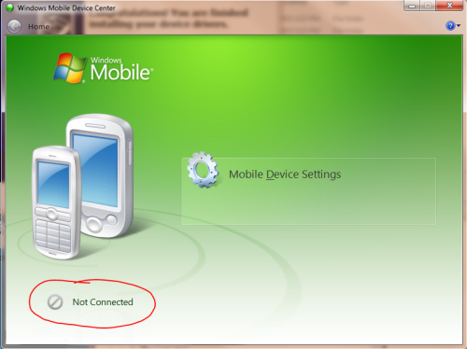
- Install the USB driver.
  - Unplug the Microlog from the Computer
  - Go to “Start” -> All Programs -> “SKF” folder (not SKF @ptitude Monitoring Suite)
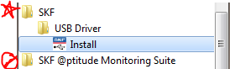
    - If you do not have an “SKF” folder go to step 2-b
    - Open SKF folder -> USB Driver -> Select “Install”
      - User Account Control Message -> Select “Yes” to allow it to make changes
      - SKF USB Device Driver Updater -> Select “Next”
      - Once done it will say “Congratulations….” And “Ready to Use” -> Finish
      - Go to Step 3 (Skip 2-b)
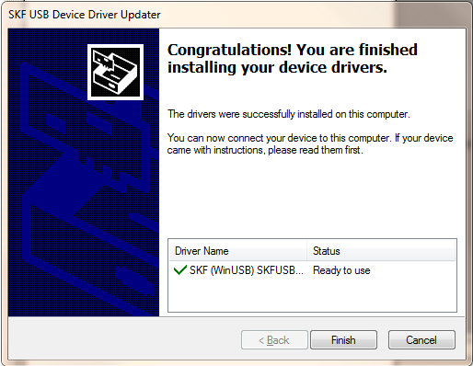
  - No SKF folder in Start Menu
    - Right Click on “Start” -> Open Windows Explorer
    - On left hand side, under “Computer” open OSDisk (C:)
    - Open “Program Files (x86)”, if you don’t have (x86) open the “Program Files”
    - Open the “SKF” folder (not skf-rs) -> Open SKF USB Driver
    - Open the “DPInst_amd64” or “DPInst_x86” (Depends on the version of windows you have, 32 bit vs. 64 bit)
      - User Account Control Message -> Select “Yes” to allow it to make changes
      - SKF USB Device Driver Updater -> Select “Next”
      - Once done it will say “Congratulations….” And “Ready to Use” -> Finish

- Further Troubleshooting - Plug the Microlog into the USB port on your computer
  - Open the Windows Mobile Device Center (Start, all Programs, windows mobile device)
  - Check if it says “Connected” or “Not Connected”
    - “Connected” – Go to Step 4
    - “Not Connected”
      - Unplug the Microlog from the computer
      - Reset the Microlog - Hold down the 7,8 and 9 Keys and Press 2 while holding 7,8,9 – The microlog should reboot to the main screen
      - Plug the Microlog back in
  - Check if it says “Connected” or “Not Connected” in Windows Mobile Device Center
    - “Connected” – Go to Step 4
    - “Not Connected”
      - Plug the microlog into a USB port on the other side of your laptop
  - Check if it says “Connected” or “Not Connected”
    - “Connected” – Go to Step 4
    - “Not Connected”
      - Restart your computer
  - Check if it says “Connected” or “Not Connected”
    - “Connected” – Go to Step 4
    - “Not Connected”
      - Call the Predictive Team (414-524-5000 options 6,1,1,5,2)

- The Microlog is communicating with Windows Mobile Device Center “Connected”
  - Open TCT -> go to “Communication” Tab -> Set Communication Type to “USB”
  - Select “Reconnect” -> Look for “Microlog Ready” at the top of the window
